

| **TITLE :Java Packages** |
| --- |

**AIM:** Create a **Package Engineering** which has two classes as **Student and Marks**. Accept (n) student details like roll_no, Subject_name, Student_name,calculate total marks in the class Student Write **display () method** to display details and **sort () method** to sort the students records as per increasing order of the total marks. The function **sort must be statically defined to invoke it without referring to any object**. Both the functions are written in the Marks class.

Create a main class which will use a package to display all the records of the student in the increasing order of their total marks.

**_____________________________________________________________________**

**Expected OUTCOME of Experiment:**

**CO4:** Explore the interface, exceptions, multithreading, packages.

**Books/ Journals/ Websites referred:**

1. Ralph Bravaco , Shai Simoson , “Java Programming From the Group Up” Tata McGraw-Hill.

2.Grady Booch, Object Oriented Analysis and Design .

**_____________________________________________________________________**

**Pre Lab/ Prior Concepts:**

**Java Packages:**

A package in Java is a group of similar types of classes, interfaces, and sub-packages. They can be categorized into two categories, the built-in package ( java, lang, util, awt, javax, swing, net, io, sql et), and user-defined package.

They are used for the following tasks –

* To prevent the naming conflicts which can occur between the classes.
* Make the searching and locating of classes or enumerations or annotations much easier.
* Provide access control to the classes.
* Used for data encapsulation.

**Advantages of Java Package:**

* A Java package is mainly used for the categorization of classes and interfaces so that we can maintain them easily.
* They always provide access protection
* Used to bundle classes and interfaces.
* With the help of packages, we can reuse the existing code
* By using the package, we can easily locate the classes related to it.
* Also, remove the naming collision.

**Built-in Packages in Java**

Built-in is a part of Java API and it offers a variety of packages are –

lang – Automatically imported and it contains language support classes.

io – Contains classes for input and output operations.

util – Contains utility classes for implementing data structures.

applet – This package contains classes that create applets.

awt – Contain classes that implement compounds for GUI.

net – This package contains classes that support networking operations.

**User-defined Packages in Java**

1. package First;
2. public class MyClass
3. {
4. public void **getNames**(String name)
5. {
6. System.out.**println**(name);
7. }
8. }
9. package First;
10. import First.MyClass;
11. public class MyClass1 {
12. public static void **main**(String args[])
13. {
14. // Initializing the String variable with a value
15. String name = "Welcome";
16. // Creating an instance of class MyClass in the package.
17. MyClass obj = new **MyClass**();
18. obj.**getNames**(name);
19. }
20. }

.

**Class Diagram:**

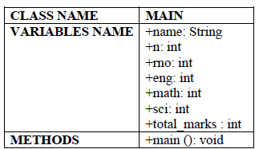

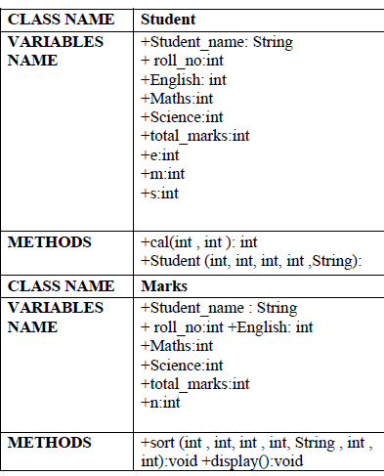

**Algorithm:**

Step 1: Create a package ‘Engineering’ having two classes: Student and Marks

Step 2: Class Student –

1. cal Function: Calculates total marks and returns it

Class Marks -

a.) sort Function: Sorts student information according to total marks

obtained. If i+1 th student (marks) < i th student(marks) swap (continue

process till n-1 iteration).

b.) display function: Displays student information

Step 3 Create MAIN class and import package ‘Engineering

Step 4: In main function accept number of students and their information.

Step 5: Store information of students in different arrays.

Step 6: call cal function and calculate total marks

Step 7: call sort function and then display the information using display function

**Implementation details:**

Main_

package exp9;

public class Main {

public static void main(String[] args) {

Student student = new Student();

student.getDetails();

student.calculateTotal();

Student sorted = Marks.sort(student);

Marks.display(sorted);

}

}

Student_

package exp9;

import java.util.Scanner;

public class Student {

Scanner scanner = new Scanner(System.in);

public int[] RollNo;

public String[] StudentName;

public int[] MarksMaths;

public int[] MarksPhysics;

public int[] MarksChemistry;

public double[] MarksTotal;

public Student() {

System.out.print("Enter the number of students: ");

int n = scanner.nextInt();

RollNo = new int[n];

StudentName = new String[n];

MarksMaths = new int[n];

MarksPhysics = new int[n];

MarksChemistry = new int[n];

MarksTotal = new double[n];

}

public void getDetails() {

for (int i = 0; i < RollNo.length; i++) {

System.out.println("\nDetails for student " + (i + 1));

System.out.print("Enter roll number of the student: ");

RollNo[i] = scanner.nextInt();

System.out.print("Enter name of the student: ");

String trash = scanner.nextLine();

StudentName[i] = scanner.nextLine();

System.out.print("Enter marks in maths: ");

MarksMaths[i] = scanner.nextInt();

System.out.print("Enter marks in physics: ");

MarksPhysics[i] = scanner.nextInt();

System.out.print("Enter marks in chemistry: ");

MarksChemistry[i] = scanner.nextInt();

}

}

public void calculateTotal() {

for (int i = 0; i < MarksTotal.length; i++) {

MarksTotal[i] = MarksMaths[i] + MarksPhysics[i] + MarksChemistry[i];

}

}

}

Marks_

package exp9;

public class Marks {

public static Student sort(Student students) {

Student sorted = new Student(students.RollNo.length);

double[] toSort = students.MarksTotal;

int[] indexArr = new int[students.MarksTotal.length];

double min;

int minInd;

for (int i = 0; i < indexArr.length; i++) {

indexArr[i] = i;

}

for (int i = 0; i < indexArr.length; i++) {

min = toSort[i];

minInd = i;

for (int j = i; j < indexArr.length; j++) {

if (toSort[j] < min) {

min = toSort[j];

minInd = j;

}

}

int temp = indexArr[i];

indexArr[i] = indexArr[minInd];

indexArr[minInd] = temp;

}

for (int i = 0; i < indexArr.length; i++) {

int ind = indexArr[i];

sorted.RollNo[i] = students.RollNo[ind];

sorted.StudentName[i] = students.StudentName[ind];

sorted.MarksChemistry[i] = students.MarksChemistry[ind];

sorted.MarksMaths[i] = students.MarksMaths[ind];

sorted.MarksPhysics[i] = students.MarksPhysics[ind];

sorted.MarksTotal[i] = students.MarksTotal[ind];

}

return sorted;

}

public static void display(Student students) {

System.out.println("\nDetails of students");

for (int i = 0; i < students.RollNo.length; i++) {

System.out.println("\nStudent " + (i + 1));

System.out.println("Student Roll Number: " + students.RollNo[i]);

System.out.println("Student Name: " + students.StudentName[i]);

System.out.println("Marks in Physics: " + students.MarksPhysics[i]);

System.out.println("Marks in Chemistry: " + students.MarksChemistry[i]);

System.out.println("Marks in Maths: " + students.MarksMaths[i]);

System.out.println("Total Marks: " + students.MarksTotal[i]);

}

}

}

**Output:**

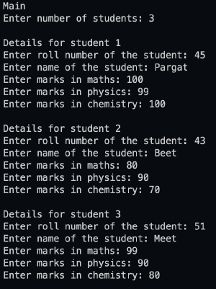

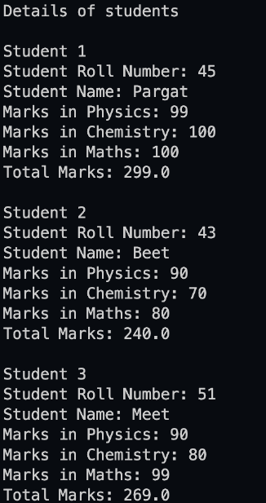

**Conclusion:**

The concept of packages is understood and successfully implemented.

**Date: __________ Signature of faculty in-charge**

**Post Lab Descriptive Questions**

Q.1   What are Java Packages? What's the significance of packages?

Packages are used in Java in order to prevent naming conflicts, to control access, to make

searching/locating and usage of classes, interfaces, enumerations and annotations easier,

etc.

A Package can be defined as a grouping of related types (classes, interfaces, enumerations

and annotations ) providing access protection and namespace management.

Since the package creates a new namespace there won't be any name conflicts with names

in other packages. Using packages, it is easier to provide access control and it is also

easier to locate the related classes.

 Q.2 Does Importing a package imports its sub-packages as well in Java?

In java, when a package is imported, its sub-packages aren’t imported and the

developer needs to import them separately if required.

For example, if a developer imports a package university.*, all classes in the package

named university are loaded but no classes from the sub-package are loaded. To load

the classes from its sub-package ( say department), the developer has to import it

explicitly as follows: Import university.department.*